

Two Months Progress Report

SIDBI PMU Rajasthan

January & February 2023

**Activities performed by PMU during January & February 2023**

|  |
| --- |
| **Details of activities carried out** |
| **Policy Advocacy** |
| **“Mukhyamantri MSME Suraksha Yojana”**   1. Prepared and submitted the concept note of “Mukhyamantri MSME Suraksha Yojana” to the Commissioner Industries. Facilitated discussion between Commissioner Industries and representative of the United India Insurance Company Limited and New India Assurance Ltd for understanding different insurance products for Micro enterprises. 2. PMU team prepared a comparative report on the basis of submitted proposals from both insurance companies and submitted to the department for further action. |
| **“Social Security Scheme for Artisan and Weavers”**   1. Working on a new scheme and initially done benchmarking of schemes of different states on social security and prepared a **concept note** and submitted to the Commissioner Industries. Further Department was interested in understanding this space further so we approached LIC regional office. 2. PMU team facilitated a meeting between Commissioner Industries and LIC regional head and it was discussed that LIC will be studying the current status of artisans and weavers in the State and will submit a proposal as soon as possible. PMU team is coordinating with the LIC team for submission of proposal as soon as possible. |
| **Enhancing Credit Flow to MSMEs** |
| **"Dr. Bhim Rao Ambedkar Udyam Protsahan Yojana for SC & ST"**   1. On 20th Jan 2023, PMU team facilitated and coordinated an **MOU between CGTMSE and Industries Department, Govt. of Rajasthan** for "Dr. Bhim Rao Ambedkar Udyam Protsahan Yojana for SC & ST". The Commissioner Industries and CEO, CGTMSE signed on the document in presence of SIDBI GM and all senior officers of Industries department. 2. **This scheme will ensure the credit guarantee under CGTMSE for the SC/ST entrepreneurs.** |
| **“Rajasthan Export Promotion Council (REPC)”**   1. Supporting Industries department in identifying credit support partner for REPC (**Rajasthan Export Promotion Council**) and facilitated various rounds of meeting between REPC and various banks (shortlisted by REPC). An MOU will be done soon and also the credit partner will support in establishment of EFC (Export Facilitation Centre) in Rajasthan under the chairmanship of Mr. Rajeev Arora. |
| **Convergence with GoI/ State Govt. Schemes** |
| **“EoDB”**   1. PMU team studied and prepared a note on proposal from Cuts International for **“Adopting and Implementing mechanisms for EoDB study and Institutionalize regulatory impact assessment in the State”**. The report has been submitted to the department. |
| **SCDF** |
| 1. PMU Team coordinated with PHED department for **various queries from SIDBI** on the Shortlisted project of PHED department. Further facilitating on requirement of additional information related to the project for final approval. 2. PMU team along with SIDBI RO team **visited SCDF project location** of PHED department (Churu and Hanumanghar) on 31st Jan 2023 - 01st Feb 2023. 3. Facilitating a **third-party report on MSME linkage** for the approved project of PHED Department. PMU team coordinating with PHED department and discussion going on with the impanelled agencies. |
| **Others** |
| 1. **"Rajasthan Udyog Ratna Award 2023 “:** - PMU team selected as a member of the preliminary selection committee and scrutinizing all applications and tentatively marking the applications as per different parameters of the selection criteria. We have received total 79 applications so far and continuously reporting the updates to the AD, Industries. |

**Snapshot of MOU between CGTMSE and Industries Department, Govt. of Rajasthan**

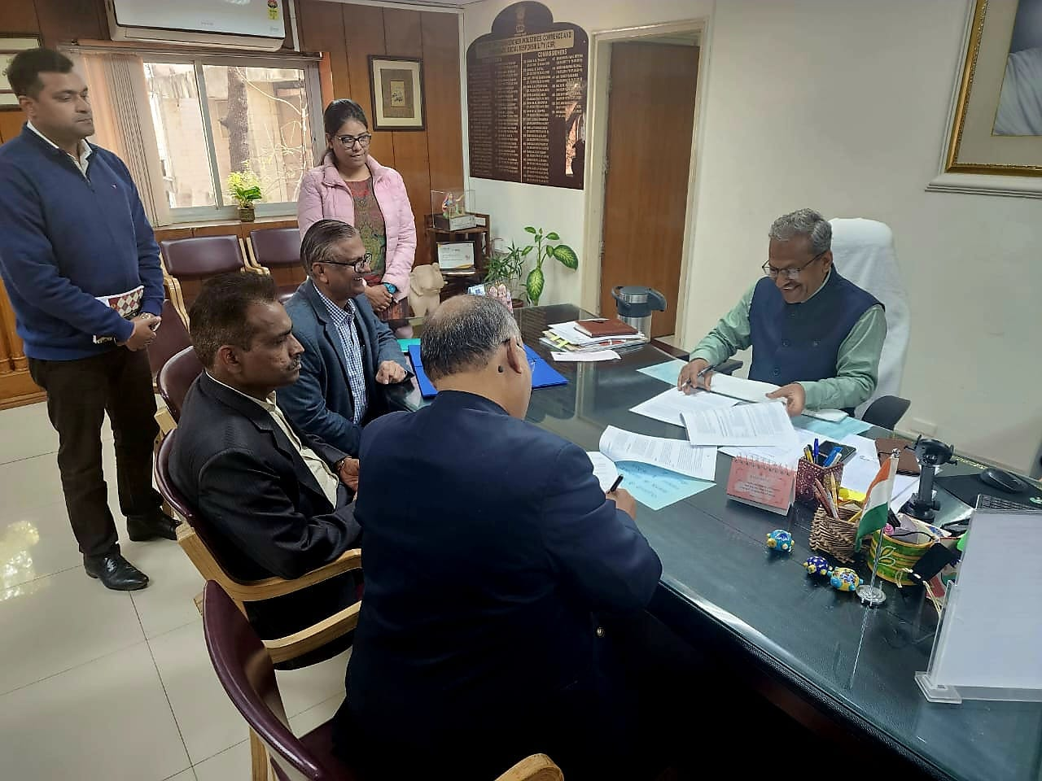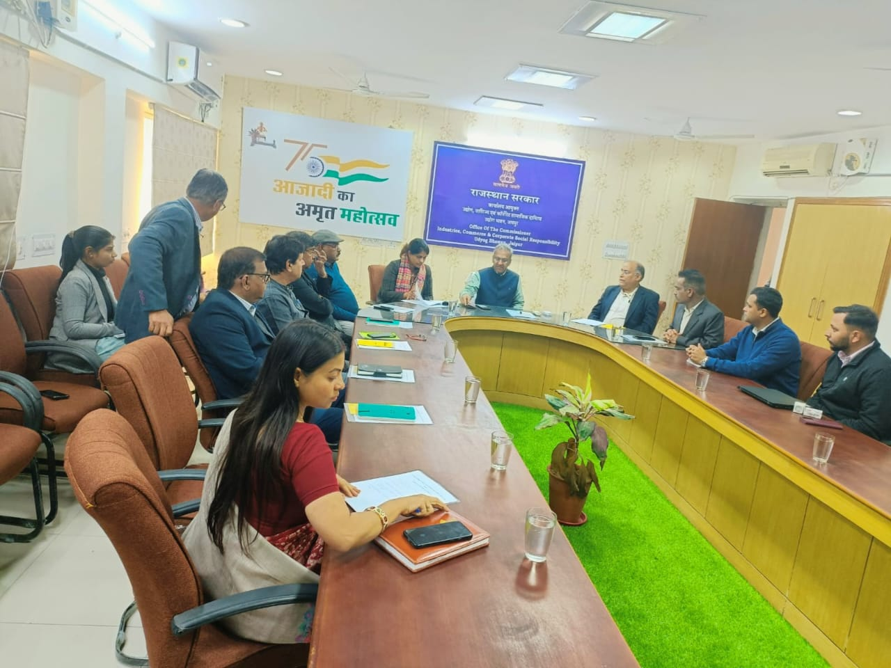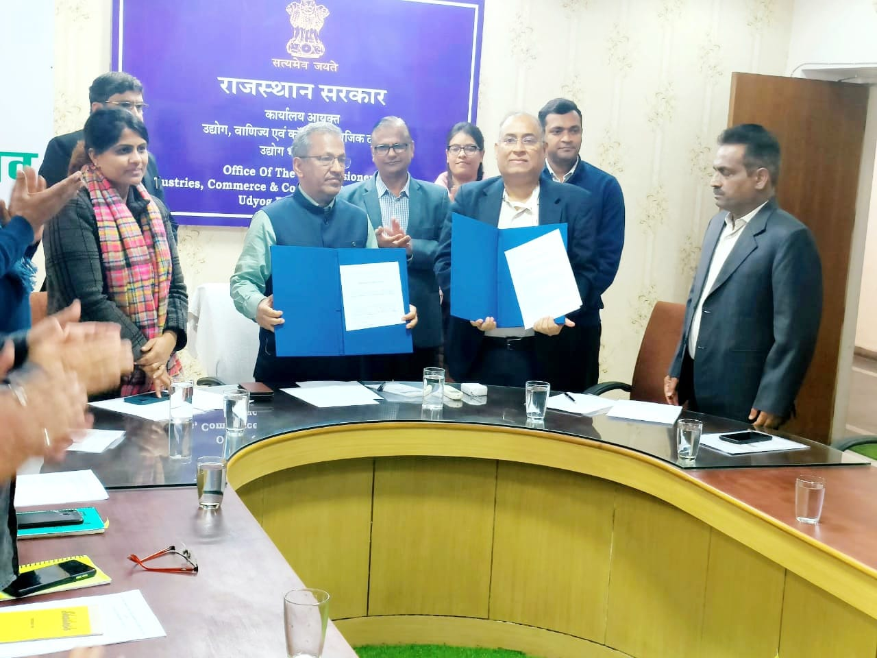

*****************

**Contact us**

To know more, please visit [**www.grantthornton.in**](http://www.grantthornton.in/) or contact any of our offices as mentioned below:

|  |  |  |  |  |
| --- | --- | --- | --- | --- |
| **NEW DELHI**  National Office, Outer Circle, L 41, Connaught Circus, New Delhi - 110001 T +91 11 4278 7070 | **NEW DELHI**  6th Floor, Worldmark 2, Aerocity,  New Delhi - 110037 T +91 11 4952 7400 | **AHMEDABAD**  7th Floor, Heritage Chambers,  Nr Azad Society, Nehru Nagar, Ahmedabad - 380015 | **BENGALURU**  5th Floor, 65/2, Block A, Bagmane Tridib, Bagmane Tech Park, CV Raman Nagar, Bengaluru - 560093  T+91 80 4243 0700 | **CHANDIGARH**  B-406A, 4th Floor, L&T Elante Office Building, Industrial Area Phase I, Chandigarh - 160002  T +91 172 4338 000 |
| **CHENNAI**  7th Floor, Prestige Polygon,  471, Anna Salai, Teynampet, Chennai - 600018  T +91 44 4294 0000 | **DEHRADUN**  Suite No 2211, 2nd Floor, Building 2000, Michigan Avenue, Doon Express Business Park,  Subhash Nagar, Dehradun - 248002  T +91 135 2646 500 | **GURGAON**  21st Floor, DLF Square, Jacaranda Marg, DLF Phase II,  Gurgaon - 122002  T +91 124 462 8000 | **HYDERABAD**  7th Floor, Block III, White House,  Kundan Bagh, Begumpet, Hyderabad - 500016  T +91 40 6630 8200 | **KOCH**I  6th Floor, Modayil Centre Point, Warriam Road Junction, MG Road Kochi - 682016  T +91 484 406 4541 |
| **KOLKATA**  10C Hungerford Street, 5th Floor,  Kolkata - 700017  T +91 33 4050 8000 | **MUMBAI**  11th Floor, Tower II,  One International Center, SB Marg Prabhadevi (W), Mumbai - 400013  T +91 22 6626 2600 | **MUMBAI**  Kaledonia, 1st Floor, C Wing, (Opposite J&J Office),  Sahar Road, Andheri East,  Mumbai - 400 069 | **NOIDA**  Plot No 19A, 2nd Floor, Sector - 16A,  Noida - 201301  T +91 120 485 5900 | **PUNE**  3rd Floor, Unit No 309- 312, West Wing, Nyati Unitree, Nagar Road, Yerwada  Pune - 411006  T +91 20 6744 8800 |

For more information or for any queries, write to us at [**contact@in.gt.com**](mailto:contact@in.gt.com)

|  |  |
| --- | --- |
| Twitter-outline | **Follow us @GrantThorntonIN** |

**Small Industries Development Bank of India (SIDBI),** established under an Act of Parliament in 1990, acts as the Principal Financial Institution for Promotion, Financing and Development of the Micro, Small and Medium Enterprise (MSME) sector as well as for co-ordination of functions of institutions engaged in similar activities. In the context of the changing MSME lending landscape, the role of SIDBI has been realigned through adoption of SIDBI Vision 2.0 which envisages an integrated credit and development support role of the Bank by being a thought leader, adopting a credit-plus approach, creating a multiplier effect and serving as an aggregator in MSME space.





***Disclaime****r: This document is prepared under SIDBI intervention in which Grant Thornton Bharat LLP is the implementing agency. The document users/third parties shall verify the facts and figures at their end and shall be solely liable for any action taken by it based on this document. SIDBI, its directors, employees or any office shall not be liable for loss of whatsoever nature arising by using the content of this document.*